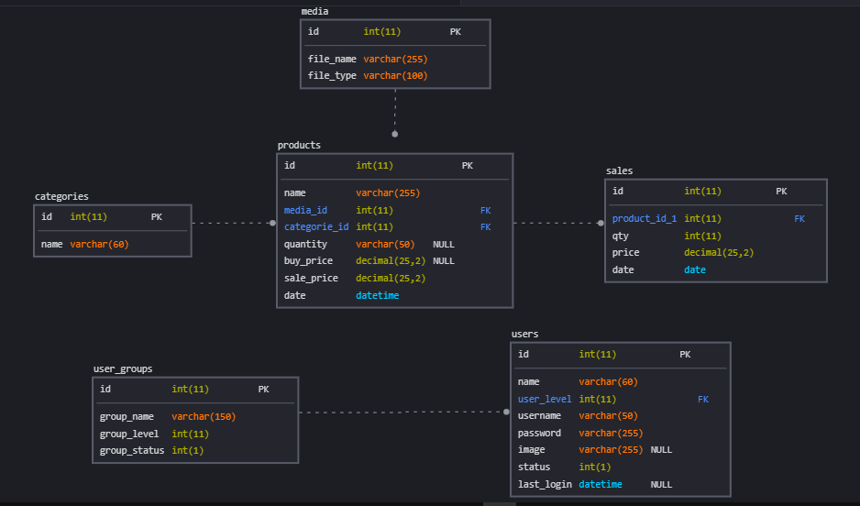

1

N

1

N

N

1

N

1